Industrial visit Report

By

Kolte shreeganesh manik

(b.c.a.(science))

INDEX

CONTAINER CORPORATION INDIA LTD.

• COMPANY PROFILE -3-10

• OBJECTIVES OF VISIT - 11

• FINANCIAL POSITION -12-14

• MARKETING STRUCTURE - 15

• PORTER'S MODEL -16

• GROUP OBSERVATIONS - 17-20

• CONCLUSION AND REFRENCES - 21

• GROUP MEMBERS - 22

• APPENDIX -22-25

**COMPANY PROFILE**

CONTAINER CORPORATION INDIA LTD.

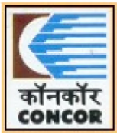

A NAVARATNA COMPANY

"Think Container Think CONCOR"

Container Corporation of India Ltd. (CONCOR) is a Navratna Public sector undertaking under the Indian Ministry of Railways. Incorporated in March 1988 under the Companies Act, CONCOR commenced operations in November 1989 taking over an existing network of seven inland container depots (ICDs) from Indian Railways. It now has a network of 61 ICDS/CFSS (Container Freight Stations) throughout India.

**MAJOR OBJECTIVES**

* To be result oriented, driven by performance, customer focused
* To provide the consumers with the value of their money The productive utilization of resources to be maximized
* To provide very high services to the consumers To be the benchmark in the standards of the service provided

**BOARD OF DIRECTORS**

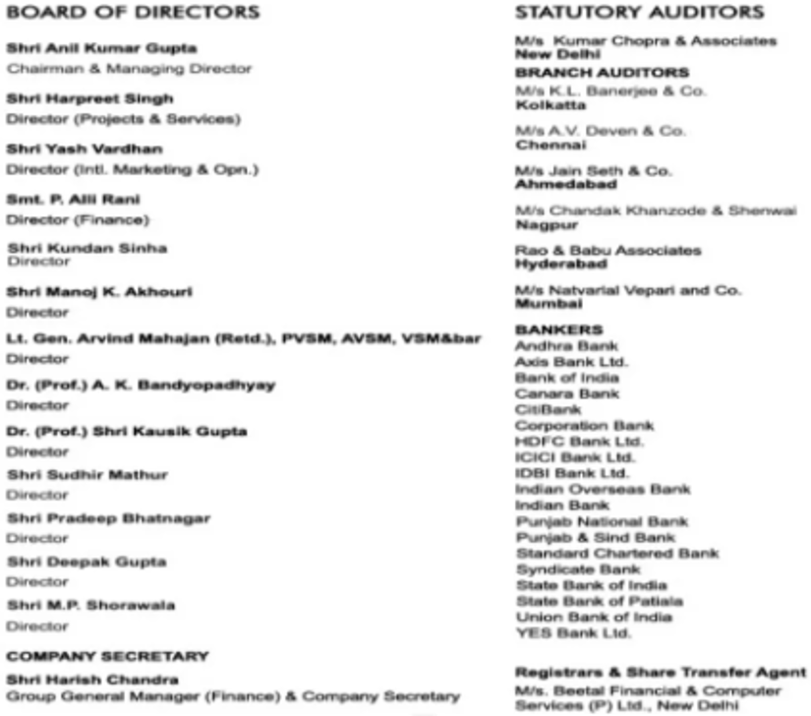**COMPANY INFORMATION**

**HISTORY OF THE COMPANY**

Indian Railway's strategic initiative to containerize cargo transport put India on the intermodal freight transport map for the first time in 1966. Given India's size (almost 3,000 kilometres (1,900 mi) from North to South and East to West), rail transport is often a cheaper option for all cargo over medium and long distances, especially if the cost of inter modal transfers can be reduced. Seeing that containerized multi-modal door-to-door transport provided a solution to this problem, in 1966 Indian Railways entered the market for moving door-to-door domestic cargo in special DSO containers.

Although the first ISO container in India had been handled in Kochi as early as 1973, it was not until 1981 that the first ISO container was moved inland by Indian Railways to the country's first ICD at Bangalore, also managed by the Indian Railways.

Expansion of the network to seven ICDs by 1988 saw an increase in container handling capacity, while along the way a strong view emerged that there was a need to set up a separate pro-active organization to promote and manage the growth of containerization in India.

**CORE BUSINESS**

CONCOR operates three core businesses

1. Cargo Carrier

2. Terminal Operator

3. Warehouse Operator

**CONCOR'S MISSION**

In the words of CONCOR

"Our mission is, To join with our community partners and stake holders to make CONCOR a company of outstanding quality. We do this by providing responsive, cost effective, efficient and reliable logistics solutions to our customers through synergy with our community partners and ensuring profitability and growth. We strive to be the first choice for our customers. We will be firmly committed to our social responsibility and prove worthy of trust reposed in us."

**ACHIEVEMENTS AND AWARDS**

1. MOU Excellence Award for four consecutive years (2004-05, 2005-06, 2006-07 & 2007-08) among top ten CPSE [citation needed][clarification needed].

2. ISO-9001:2000 quality systems certification for 35 Terminals/units obtained up to financial year 2007-08. 16 terminals/units certified to ISO 9001:2008 standards in financial year 2008-09[citation needed].

3. CONCOR was recognised as the top Indian company in the shipping and logistics sector in the Dun & Bradstreet-American Express corporate awards, 2007 & 2008 consecutively.

4. CONCOR has received a corporate excellence award from Amity

International[who?] for the year 2007.

5. Obtained ISO/IEC 27001-2005 certification from STQC for its certification services to the (Ministry of Communication and Information Technology) for establishing an Information Security Management System (ISMS).

6. CONCOR won an award for the "Web Based integrated container/terminal management system" project judged by AFACT.

**STATUS OF CONCOR IN MARKET**

The Department of Public Enterprises, Govt. of India granted the much coveted Navratna status to Container Corporation of India Limited (CONCOR) with effect from July 23, 2014. CONCOR, the market leader in the logistics segment in India thus adds another feather to its cap, already adorned by several awards by reputed agencies for its performance both in its operations and in the stock market. CONCOR manages the largest network of Dry ports in the country and has introduced and promotes the concept of multimodalism in transport of goods both in the International and Domestic segments. The company has constantly strived to facilitate faster and more efficient movement of goods by expanding and upscaling its infrastructure. Currently, CONCOR is fast progressing towards its goal to create Logistics infrastructure that would enable customers to access a single window for all their logistics requirements like multi-modal transport, state of art specialized storage, packaging etc at large facilities called "Logistics Parks"

**INTERNATIONAL SERVICES**

* Train Services
* Block Booking on Round Trip Basis
* Road Services
* LCL Hub Services
* Air Cargo Services
* Bonded WareHousing
* Reefer Services
* Factory Stuffing/Destuffing
* Discount Schemes
* Cabotage of ISO container
* CONCOR's Policy On Waiver of Terminal Service Charges

**DOMESTIC SERVICES**

* Train Services
* Volume Discount
* SchemeDoor Delivery/Pick up
* Cabotage of ISO containers
* Terminal Handling Charges

**CONTACT ICD PITHAMPUR(INDORE)**

|  |  |
| --- | --- |
| Address | Container Corporation of India Ltd. Inland Cotainer Depot, Plot No. 113, Mhow Neemuch Road, Sector III, Pithampur 454774 Dhar Distict, Madhya Pradesh |
| Phone | 07292-503701-7, 256154, 256545 |
| E-mail | Indo@concorindia.com |
| Fax | 07292-256424 |

|  |  |  |
| --- | --- | --- |
| Name & Designation | Phone No | Email |
| K. Sivramakrishna Chief Manager | 0731-2565408 | srkrishna@concorindia.com |

**OBJECTIVES OF THE VISIT**

**CONTAINER CORPORATION INDIA LTD.**

Industrial visit CONCOR INDIA LTD. Pithampur was organized by MEDICAPS for the Foreign Trade Students. The guiding staff on site was very supportive to all students. We are sure that this visit will help us in our future practical life and bring a positive change in our thinking and practical behavior regarding Education and specializing our skills.

**TECHNICAL OBJECTIVES**

1. . In order to learn the practical process of DOCUMENTATION in EXIM trade.
2. In order to have a brief overlook on the LOGISTICS activitiesconducted by CONCOR.
3. In order to learn about different kinds and sizes of containers used by CONCOR.
4. In order to learn about the proper handling and storage of containers, different policies regarding auctions and other further activities in concern with containers.

**MANEGERIAL OBJECTIVES**

1. In order to know about managerial structure of CONCOR.
2. To learn Container management,labour and full logistics management.
3. And other managerial activities conducted by CONCOR.

**FINANCIAL POSITION OF THE COMPANY**

|  |  |
| --- | --- |
| **Latest Financial figures** | **(figures in Rs. Crores)** |
| **ET 500 Rank(2011)** | **187** |
| **Industry** | **Transport Road** |
| **Turnover** | **4030.94** |
| **Profit after Tax(PAT)** | **875.94** |
| **MCAP(Market Capitallization)** | **12602.48** |
| **Assets** | **4986.11** |

**FINANCIAL SUMMERY**

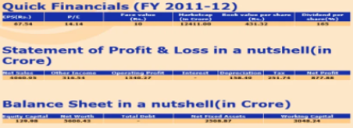

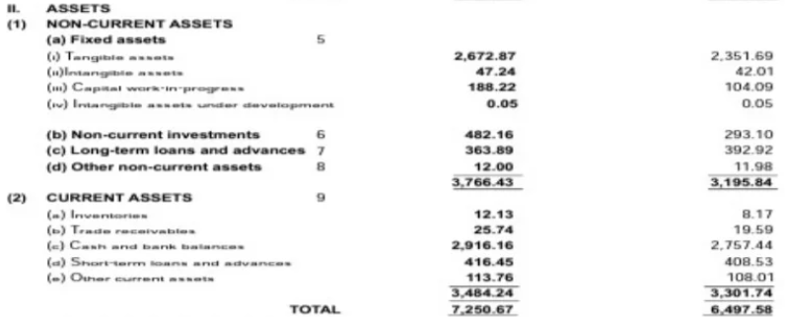**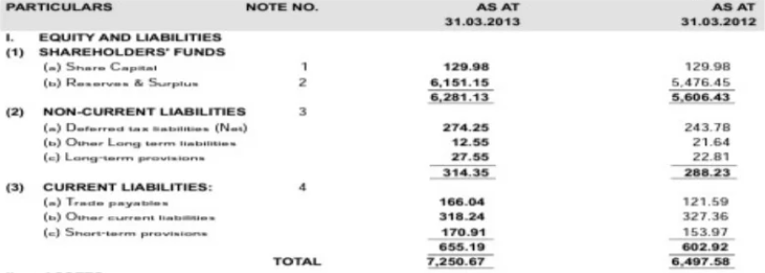BALANCE SHEET**

**PROFIT AND LOSS ACCOUNT, RESERVE AND SURPLUS**

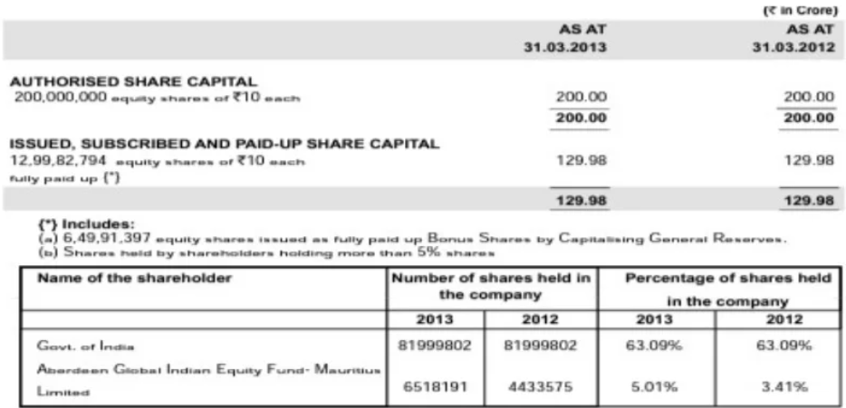

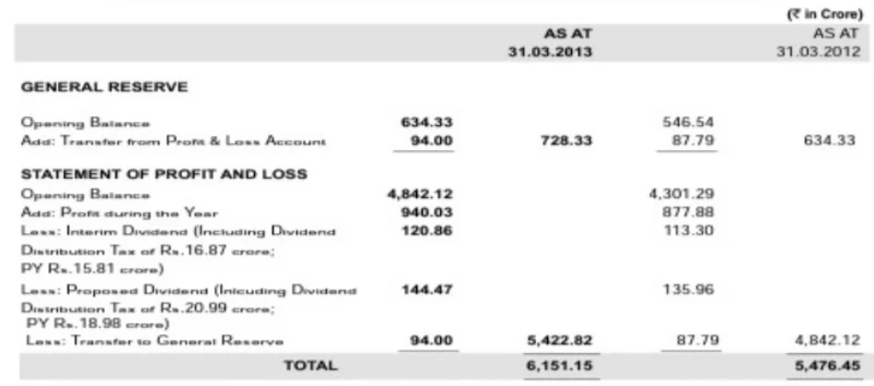**RESERVE AND SURPLUS**

**MARKETING**

**MANAGEMENT/ORGANISATION STRUCTURE**

**Container Corporation INDIA LTD.**

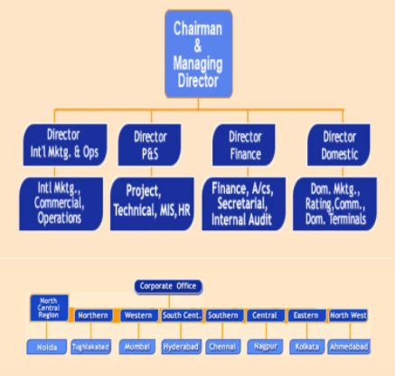

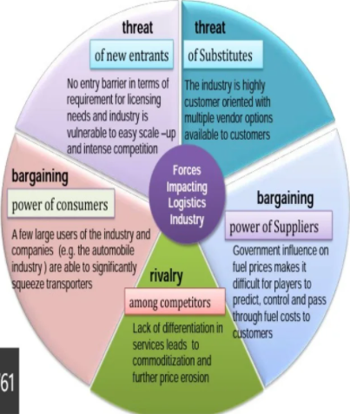**PORTER’S FIVE FORCES MODEL ANALYSIS IN TERMS OF CONCOR**

**GROUP OBSERVATIONS AND LEARNINGS**

**CONTAINER CORPORATION INDIA LTD.**

The following is a list along with photographs and specifications of various types of containers which we had observed during our industry visit.

* There are a number of activities conducted by COCNCOR which is a dry port like loading and unloading of goods and containers.
* All the loading and unloading activities are done by machines and

labours.

* There is a proper management and utilization of manpower and machines.
* In the mean while of our visit we have observed different types of by COCNCOR mentioned below in details

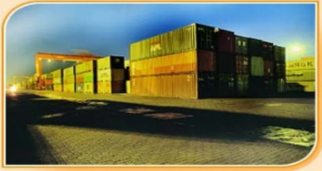

20/40 ft. conventional end open containers : These are usually built to ISO standards, and are used for the movement of conventional dry cargo. For domestic

Movement, CONCOR has inducted a fleet of approx. 12000 such 20 ft. containers either under direct ownership or on lease for internal movements within the country.

20/40 ft High Cube Containers : These containers offer the added advantage of extra volumetric capacity due to their additional height, and are especially useful of movement of light but bulky cargo.

20 ft Side Access Containers : These containers are used exclusively for domestic traffic movements within the country. They offer the advantage of having doors on theside panels, and this makes it convenient for use in locations where chassis stuffing operations have to be used. CONCOR has currently about 3300 such self owned domestic SA containers in its fleet.

22 ft/High Cube Domestic Containers : These containers have

also been exclusively introduced by CONCOR for the purpose of carrying cargo that requires greater volumetric capacity or container length. CONCOR has currently about 2000 such self owned domestic 22ft containers in its fleet.

**SOCIAL RESPONSIBILITY**

**CONTAINER CORPORATION INDIA LTD.**

Corporate Social Responsibility

CONCOR Management has nominated a committee comprising of senior officers to identify and deliver the activities pertaining to corporate social responsibility. Employees voluntarily involve themselves to render community service activities such as tree planting programs.

As a socially responsible organization CONCOR has done substantial work in the area of Corporate Social Responsibility. An essential component of our Corporate Social Responsibility is to take care of the community. We endeavor to make a positive contribution to the unprivileged community by supporting a wide range of socio-economic, educational and health intiatives.

Contribution was made by CONCOR to Prime Minister Relief Fund towards help to Jammu & Kashmir earthquake victims and also to Railway Minister's Fund.

CONCOR is spearheading a movement for rural transformation of the adjoining areas of the Inland Container Depot located at Dadri, Greater Noida, U.P. in the vicinity of Delhi (approx. 45 Kms.) as a part of its Corporate Social Responsibility. This comprises and covers the field of education, health, rural road linkages and community development centers.

CONCOR has carried out the following development programmes in Tilapata and Palli villages adjoining ICD-Dadri:

* Extension of Primary school at Palli Village.
* Construction of road about 3 Kms, at Palli Village.
* Community center at Tilapata village .
* Two minor bridges both at Palli and Tilapata.
* Cremation ground at Tilapata village.
* Pond development at Palli village.
* Development near temple area at Palli.

**CONCLUSION AND REFERENCES**

**CONCLUSION**

**CONTAINER CORPORATION INDIA LTD.**

We are thankful to our for faculties for organizing such an informative event for us in crucial to develop our practical skills regarding logistics and documentation or other managerial activities. We have learnt the proper management criteria of the dry port and have an opportunity to research on the company.

We hope we get more chances further to have such wonderful and informative experiences of visiting different industries.

**REFRENCES**

**CONTAINER CORPORATION INDIA LTD.**

Following channels played an important role in the data gathering of our report.

* [WWW.CONCORINDIA.IN(OFFICIAL)](http://WWW.CONCORINDIA.IN(OFFICIAL))
* WIKIPEDIA
* PDF DOCUMENTS FROM GOOGLE
* POINTS NOTED BY US AT THE TIME OF VISIT

**GROUP MEMBERS**

**CONTAINER CORPORATION INDIA LTD.**

1. **Kolte Shreeganesh Manik.**

**APPENDIX**

**CONTAINER CORPORATION INDIA LTD.**

PICTURES CLICKED BY GROUP DURING VISIT

